1. Write a food ordering application to a restaurant to insert the order details such as item name, item quantity into the MongoDB.
2. Write a food ordering application to a restaurant to view all the order details such as item name, item quantity from the MongoDB.

**Front-end:**

**App.js**

import logo from './logo.svg';

import './App.css';

import { Route, BrowserRouter as Router, Routes } from 'react-router-dom';

import Order from './Order';

import View from './View';

function App() {

  return (

    <div className="App">

      <Router>

        <Routes>

          <Route path='/' element={<Order />}/>

          <Route path = '/view' element = {<View />}/>

        </Routes>

      </Router>

    </div>

  );

}

export default App;

**Order.jsx**

import React, { useState } from 'react';

import axios from 'axios';

export default function Order(){

    const [name, setName] = useState('');

    const [quantity, setQuantity] = useState();

    const handleClick = async()=>{

        const result = await axios.post('http://localhost:7000/', {name, quantity});

        document.getElementById('id1').innerHTML = result.data;

    }

    return(

        <div>

            <h2> Ordering the food items page </h2>

            <input type='text' placeholder = 'food name' onChange={(e)=>setName(e.target.value)}/>

            <input type='text' placeholder = 'food quantity' onChange={(e)=>setQuantity(e.target.value)}/>

            <button onClick={handleClick}>click me </button>

            <h2 id='id1'></h2>

        </div>

    );

}

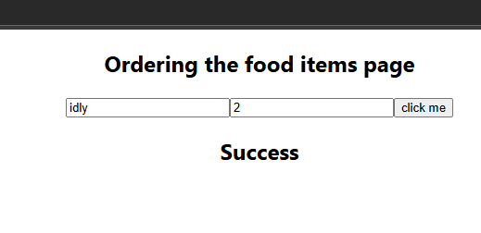

**View.jsx**

import React, { useState } from 'react';

import axios from 'axios';

export default function View(){

    const [outpu, setOutput] = useState([]);

    const handleClick = async()=>{

        const res = await axios.get('http://localhost:7000/');

        setOutput(res.data);

    }

    return(

        <div>

            <h2> Viewing the items ordered by many users </h2>

            <button onClick={handleClick}> Click me </button>

            {/* {JSON.stringify(outpu)} */}

            {outpu.map(item=><li>{item.itemname}: {item.itemquantity}</li>)}

        </div>

    );

}

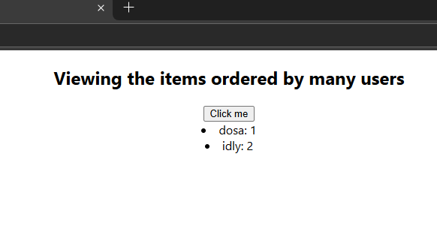

**Back-end:**

const express = require('express');

const app = express();

const cors = require('cors');

app.use(cors());

const bodyParser = require('body-parser');

app.use(bodyParser.json());

app.use(express.urlencoded({extended: true}));

app.listen(7000, ()=>{

    console.log('Our server is waiting for the client..');

});

const {MongoClient} = require('mongodb');

const client = new MongoClient('mongodb://localhost:27017');

app.post('/', async (req,res)=>{

    const result = await client.db('ordermgmgdb').collection('col1').insertOne({'itemname': req.body.name, 'itemquantity': req.body.quantity})

    if(result.acknowledged == true){

        res.send('Success');

    }

    else{

        res.send('Fail');

    }

    res.end();

});

app.get('/', async (req, res)=>{

    const result = await client.db('ordermgmgdb').collection('col1').find().toArray();

    console.log(result);

    if(result.length != 0)

        res.json(result);

    else

        res.send('Update failed');

    res.end();

});